10/3/2023

Dale Randall

GMCA 4– Day 1 MySQL Tasks

Mr Dale Randall

Query 1

USE sql_store;

Select *

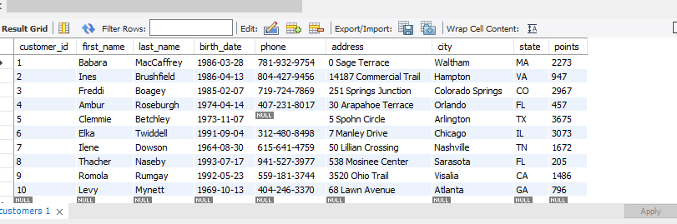From customers

Query 1 Continued..

USE sql_store;

Select *

From customer  
WHERE CUSTOMER_ID=1

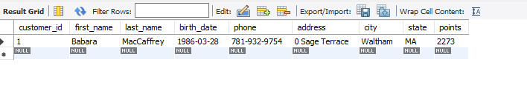ORDER BY first_name;

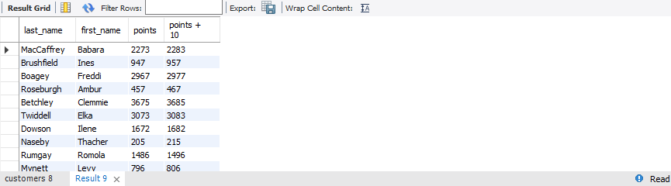Query 2  
  
SELECT last_name, first_name, points, points + 10   
FROM CUSTOMERS;

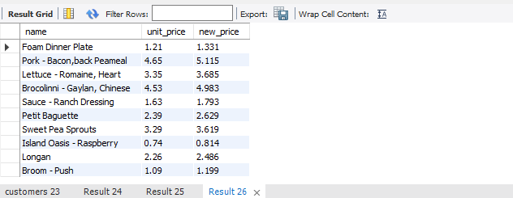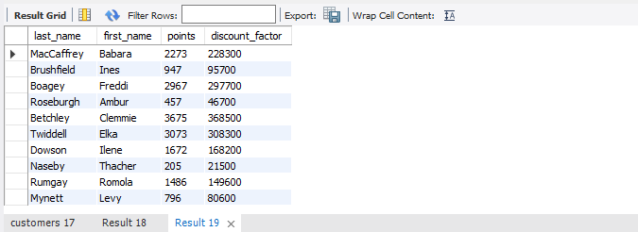Task 1  
  
SELECTT last_name, first_name, points, (points + 10) * 100 as discount_factor   
FROM CUSTOMERS;  
  
  
  
Task 2  
  
SELECT name, unit_price, (unit_price*1.1) as new_price   
FROM products;

Task 3  
  
SELECT * FROM customers  
WHERE birth_date >'1990-01-01';

Task 4  
  
USE sql_inventory;

Select * From products

ORDER BY quantity_in_stock desc

LIMIT 1;

Task 5

USE sql_inventory;

Select * From products

ORDER BY unit_price DESC

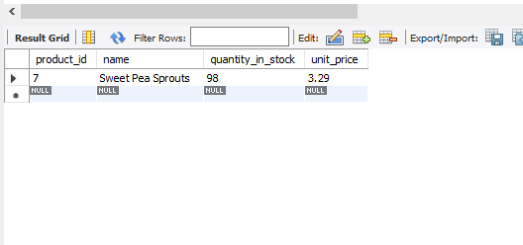LIMIT 1;

Task 6

USE sql_store;

SELECT last_name, first_name, address, birth_date

from customers

ORDER BY birth_date ASC

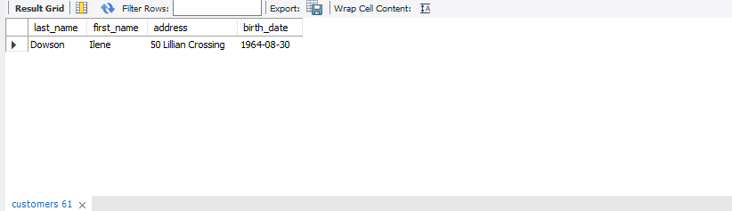LIMIT 1;

EER Diagram

